讲师介绍
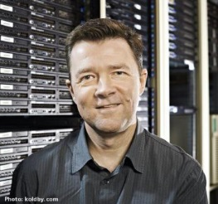 Christian Jensen, Aalborg University, Denmark
Christian S. Jensen is an Obel Professor of Computer Science at Aalborg University, Denmark. He was a Professor at Aarhus University for a 3-year period from 2010 to 2013. Prior to that, he was a Professor at Aalborg University, Denmark. During the 1990s, he spent four sabbaticals at University of Arizona, and he recently spent a one-year sabbatical at Google Inc., Mountain View. He received the Ph.D. degree from Aalborg University in 1991 after 2 1/2 years of study at University of Maryland, and he received the Dr. Techn. degree from Aalborg University in 2000. His research concerns data management and data-intensive systems, and it concerns primarily temporal and spatio-temporal data management. He is an ACM and an IEEE fellow, and he is a member of the Academia Europaea, the Royal Danish Academy of Sciences and Letters, the Danish Academy of Technical Sciences, and the EDBT Endowment, as well as a trustee emeritus of the VLDB Endowment. He received the Ib Henriksen Research Award 2001 for his research in mainly temporal data management, Telenor's Nordic Research Award 2002 for his research in mobile services, and the Villum Kann Rasmussen Award for Technical and Scientific Research 2011 for his general research contributions. He is Editor-in-Chief of ACM TODS and an Editor-in-Chief of The VLDB Journal, and he is an Area Editor (temporal databases) for the Encyclopedia of Database Systems. He has served on the editorial boards of ACM TODS, IEEE TKDE, and the IEEE Data Engineering Bulletin. He was PC chair or co-chair for SSTD 2001, EDBT 2002, VLDB 2005, MobiDE 2006, MDM 2007, DMSN 2008, TIME 2008, ACM SIGSPATIAL GIS 2011, AP Web 2012, IEEE ICDE 2013, and DASFAA 2014.
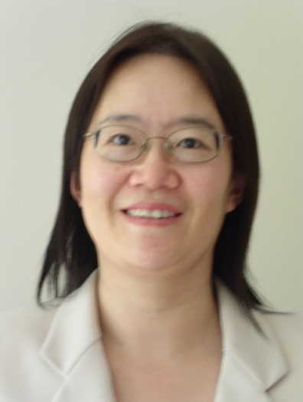 Ling Liu, Georgia Institute of Technology, USA
Ling Liu is a Professor in the College of Computing at Georgia Institute of Technology. There she directs the Distributed Data Intensive Systems Lab, working on systems performance, availability, security and privacy in data intensive systems, ranging from service oriented computing and architectures, big data systems and technology, cloud computing, social computing, mobile services, to Internet systems and services. Professor Liu has published over 300 international journal and conference articles, and her research group has produced a number of open source software systems. She is a recipient of the IEEE Computer Society Technical Achievement Award in 2012, an Outstanding Doctoral Thesis Advisor award from Georgia Institute of Technology and numerous best paper awards, including ICDCS, WWW, ICWS, IEEE Cloud. In addition to services as General chair and PC Chair of numerous IEEE and ACM conferences, Professor Liu has served on the editorial boards of many international journals. Currently Professor Liu is the Editor in Chief of the IEEE Transactions on Service Computing and a member of the steering committee of IEEE International Conference on Data Engineering (ICDE). Professor Liu's current research is primarily sponsored by NSF, IBM and Intel.
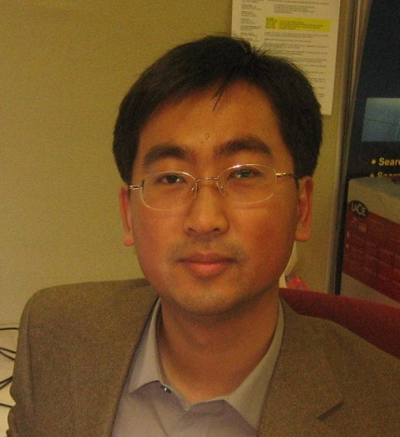 Xing Xie博士, MSRA(微软亚洲研究院)研究员
Dr. Xing Xie is currently a senior researcher in Microsoft Research Asia, and a guest Ph.D. advisor for the University of Science and Technology of China. He received his B.S. and Ph.D. degrees in Computer Science from the University of Science and Technology of China in 1996 and 2001, respectively. He joined Microsoft Research Asia in July 2001, working on spatial data mining, location based services, social networks and ubiquitous computing. During the past years, he has published over 140 referred journal and conference papers. He has more than 50 patents filed or granted. He currently serves on the editorial boards of ACM Transactions on Intelligent Systems and Technology (TIST), Springer GeoInformatica, Elsevier Pervasive and Mobile Computing, Journal of Location Based Services, and Communications of the China Computer Federation (CCCF). He has worked as a guest editor of IEEE Transactions on Multimedia and IEEE Intelligent Systems. In recent years, he was involved in the program or organizing committees of over 70 conferences and workshops. Especially, he initiated the LBSN workshop series and served as program co-chair of ACM UbiComp 2011 and program chair of the 8th Chinese Pervasive Computing Conference (PCC 2012). In Oct. 2009, he founded the SIGSPATIAL China chapter which was the first regional chapter of ACM SIGSPATIAL. He is a member of Joint Steering Committee of the UbiComp and Pervasive Conference Series. He is a senior member of ACM, the IEEE, and China Computer Federation (CCF).

